Budget Rent-a-Car
of British Columbia

Rate Uploading Tutorial

Version 1.00

Note: The information contained in this document is confidential and may not be disclosed to any parties outside of Budget Rent-a-Car of British Columbia Ltd. without written consent by one of its officers.
Copyright (C) 2010 Budget Rent-a-Car of British Columbia Ltd.
Entering Location Vehicle Rates

You can assign different rates for each vehicle class for each rental location in GIS through the Location Maintenance screen. We also provide an easier option to upload the rates into GIS through the GIS Maintenance Tool, which can be accessed from C:\Program Files\GIS\GISMaintenance.adp.

Let’s bring up the GIS Maintenance Tool (See Figure 1). If this window does not appear, you have to manually open it through the project menu. On the left hand panel, click on Forms from the Objects section and select Switchboard (see Figure 2) to bring up Figure 1.

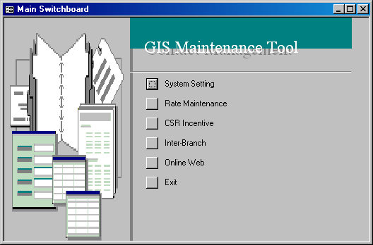
Figure 1: The main menu of the GIS Maintenance tool.

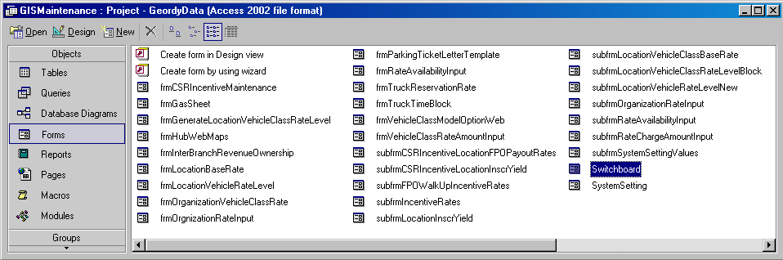
Figure 2: Opening the GIS Maintenance main menu manually through the project screen.

From the main menu of the GIS Maintenance tool, select Rate Maintenance. Note that you can only select Rate Maintenance and not the other menu items as they are only accessible by users with permissions. Select Location Vehicle Class Rate next. The Location Vehicle Class Rate screen will appear and you should see the Location VC Rate Level Gen sub-screen by default, as shown in Figure 3.

Switch to the Location VC Rate Level sub-screen and select Clear Clipboard. This action merely clears any previously entered/generated rates from the screen so that you will only see the rates that you are about to add. You should make it a habit of clearing the clipboard every time before you enter rates in the GIS Maintenance Tool.

To enter rates, you need to populate each column in the Location Vehicle Class Rate screen starting from the Location column. Populate the Vehicle Class, Rate and Rate Level cells next. In the Rate Type column, select one from the three possible choices – Future, Same Day, Walk Up. ‘Future’ and ‘Same Day’ are normally used for reservations. When your res agents make bookings for customers for a future date, you might want to offer a cheaper rate as opposed to a higher rate when customers make reservations on the day they want to rent a vehicle. When a customer walks up to your counter at your location to rent a car, your have the flexibility to assign a higher walk up rate than the rate you offer during reservations. Note that it is not necessary to have 3 distinct sets of rates for Future, Same Day and Walk Up, but if you ever need to distinguish the rates, GIS offers you the flexibility to do so.

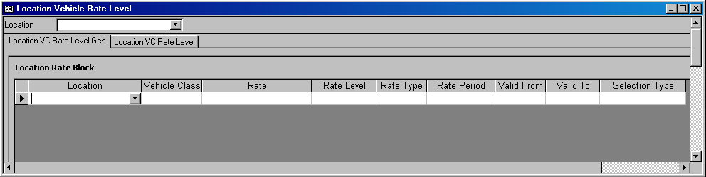
Figure 3: The Location Vehicle Class Rate screen.

The Rate Period drop down list offer a selection from Weekday, Weekend, Weekly, Oneway and All, and is linked with both the Valid From and Valid To fields. ‘Weekday’ means every Monday, Tuesday, Wednesday and Thursday in your valid rate period. ‘Weekend’ refers to Friday, Saturday and Sunday in your valid rate period. ‘All’ refers to every day in the specified rate period.

The Valid From and Valid To Dates control when the rate may be used for rentals. The Selection Type identifies the nature of the rate, which is Rack, Package or Promotion. A rack rate is the default rate which will be applied to the reservation or contract after the CSR enters the pick up and drop off locations/dates and vehicle class. A package rate is a special discounted rate for the vehicle class you specify. A promotion rate is a little tricky. You might confuse it with a package rate but the logic behind this rate is very different from the former. The definition of a promotion rate would probably be better explained with the following example. Let’s say we want to create a promotion rate for vehicle class Premium. In our GIS settings, a Premium car can be upgraded from a Full Size 4Door and can also be upgraded to a Luxury vehicle. If the Full Size 4Door and Luxury each (or both) has a promotion rate, then when you make a reservation for a Premium, you will also be able to select from the two promotion rates for Full Size 4Door and Luxury in the View Rates window in the Reservations and Contract Open screens. But if your Full Size 4Door and Luxury cars also come with package rates, unlike promotion rates, their package rates will not appear when you make a reservation for a Premium car.
Location: B-01 YVR Airport  Vehicle Class: Full Size 4Door  Rate & Level: Weekly95RB - O  Rate Type: Same Day  Rate Period: All  Valid on: 11/9/2010  Selection Type: Promotion | Location: B-01 YVR Airport  Vehicle Class: Premium  Rate & Level: Weekly95RB - U  Rate Type: Same Day  Rate Period: All  Valid on: 11/9/2010  Selection Type: Promotion | Location: B-01 YVR Airport  Vehicle Class: Luxury  Rate & Level: Weekly95RB - J  Rate Type: Same Day  Rate Period: All  Valid on: 11/9/2010  Selection Type: Promotion
Table 1: Three promotion rates for Full Size 4Door, Premium and Luxury.

IMPORTANT
There can only be one and only one rack rate for any given scenario. Note that one scenario is equivalent to one row in the Location Vehicle Rate Level Gen sub-screen, as shown in Figure 4. There is no restriction for ‘Package’ and ‘Promotion’.

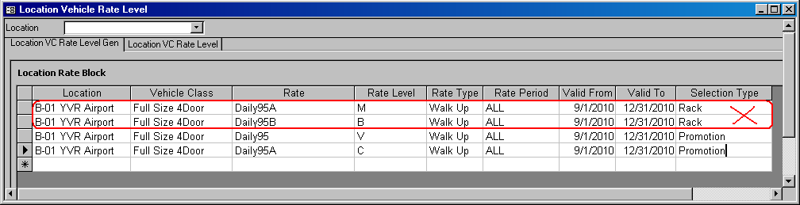
Figure 4: You cannot assign two different rates as the rack for the same location, vehicle class, rate type, rate period and valid rate period.

TIP!
If you want to delete a record without having to populate the rest of the columns, hit the ESC key.

Now, entering rates row by row might prove to be a little tedious if you have to cover multiple vehicle classes at multiple locations. To make your life easier, we have prepared an Excel rate sheet (See Figure 5) for you to enter your rates, and you can copy and paste them directly into the Location VC Rate Level Gen screen.

IMPORTANT
You can prepare your rates in any way you want in the Excel file but you must have all your rates in the exact order of Location, Vehicle Class, Rate Name, Rate Level, Location Vehicle Rate Type, Rate Period, Valid From, Valid To and Rate Selection Type when you copy and paste them into the maintenance tool.

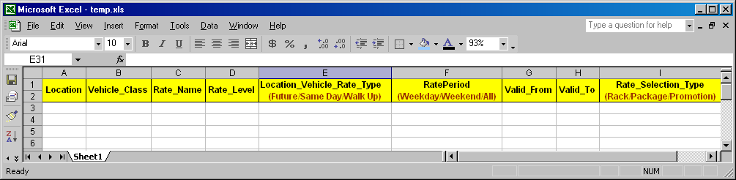
Figure 5: You can easily duplicate and change rates in the given Excel spreadsheet before copying them over to the GIS Maintenance Tool.
As you enter your rates in Excel, be extra careful so that there are no extra spaces or characters in front of the values you enter. Have a look at the sample Excel sheet below which contains the rates for Full Size 4Door and Luxury at B-01 YVR Airport. Feel free to create you own set of rates if you do not want to use the rates provided in this example. However, if you are using the sample provided, change the valid rate period to future dates for testing purposes.

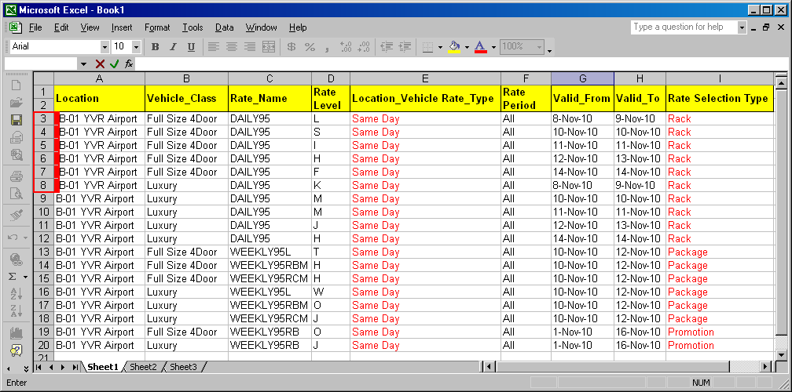
Figure 6: The first 6 rows have an extra space highlighted in red in the beginning.

Notice that rows 3-8 include a blank space in front of the location and you are bound to get an error when you copy and paste these 17 rows into the GIS Maintenance Tool. Let’s try it out: Copy all the rows in Excel, right-click on the left-most cell with a black arrow and click Paste (See Figure 7) to paste all the copied rows.

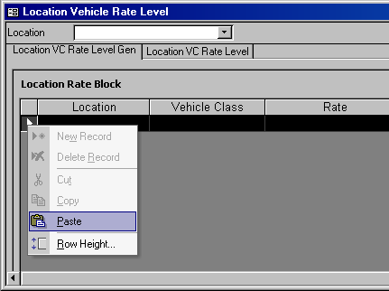
Figure 7: Copy and paste the selected records to the GIS Maintenance Tool.

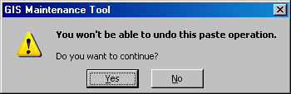
Figure 8: Copy and paste the selected records from Excel to the GIS Maintenance Tool.

Recall that you should always clear the clipboard before pasting your rates, so go ahead and clear the clipboard first. Once you hit Paste, Figure 8 will appear and you can ignore it by clicking ‘Yes’. Now comes the real problem. Right after you hit ‘Yes’, an error message pops up telling you that the text you are about to paste is not in the list, as shown in Figure 9. Recall that ‘..B-01 YVR Airport’ is not in the list because of the extra space at the beginning. The actual location is ‘B-01 YVR Airport’. Close that window and another error message pops up (See Figure 10).

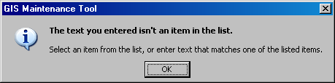
Figure 9: An error message appears because of the extra space in the Excel sheet.

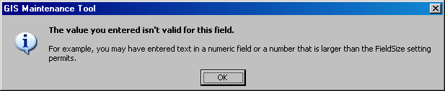
Figure 10: Another error message that appears because of the extra space in the Excel sheet.

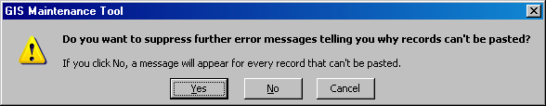
Figure 11: If you select Yes, then all the copied records that are correct-in-format will be pasted and those that have extra spaces or formatting errors will be ignored. If you select No, then an error message will appear for each record that cannot be pasted.

We can trace all these error messages back to the extra space in the rows 3-8 in the Excel sheet show in Figure 6. When you close the error message, another message, as shown in Figure 11 appears. Click Cancel to ignore it and we’ll return to the Excel sheet to fix the problem. But before you return to your Excel sheet, clear the clipboard in the Location VC Rate Level sub-screen. In the Excel sheet, remove the extra spaces in rows 3-8 and re-copy and paste the records again. This time the records are pasted successfully, as shown in Figure 12. Note that if you are copying and pasting too many records, the GIS Maintenance Tool will take a while to show all the pasted rows. Just be patient and leave the window as is when you are pasting too many records in one go.

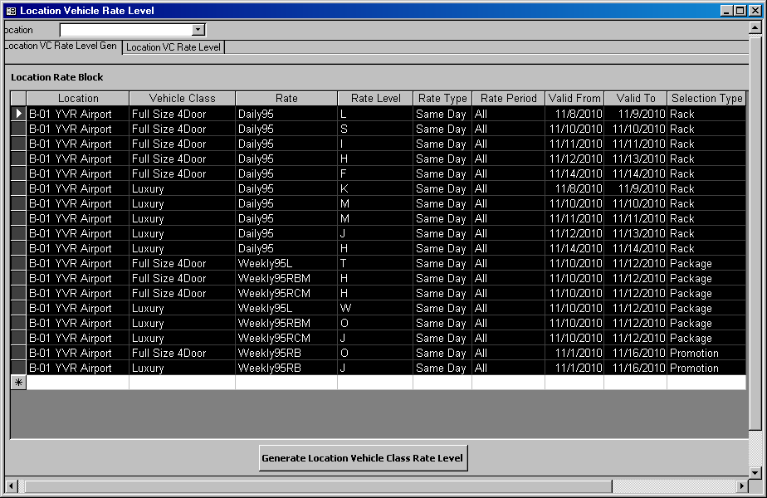
Figure 12: All records are displayed if the paste was successful.

In GIS, rates have to be assigned daily to a vehicle class at any location in order for them to appear in the Rate Details screen in Reservations and Contract Open. But when you create the rates in your Excel sheet, your valid date period is usually in the form of a date range. So we need to apply the same rate scenario to each day specified in the valid date period according to the rate period and you do so by clicking on Generate Location Vehicle Class Rate Level to generate the daily rates (See Figure 13). For example, if a record contains the following values:

Location: B-01 YVR Airport
Vehicle Class: Full Size 4Door
Rate & Rate Level: Daily95A – L
Rate Type: Same Day
Rate Period: Weekday
Valid From – Valid To: 11/8/2010 – 11/15/2010
Selection Type: Rack

Recall that the definition of a ‘Weekday’ is Monday, Tuesday, Wednesday and Thursday. So what the Generate Location Vehicle Class Rate Level button will do is create the same rate scenario for the Monday, Tuesday, Wednesday and Thursday in Nov 8 – Nov 15, which is shown in the table below.

Location | Vehicle Class | Rate | Rate Level | Rate Type | Rate Period | Valid From | Valid To | Selection Type
B-01 YVR Airport | Full Size 4Door | DAILY95A | L | Same Day | Weekday | 8-Nov-10 | 8-Nov-10 | Rack
B-01 YVR Airport | Full Size 4Door | DAILY95A | L | Same Day | Weekday | 9-Nov-10 | 9-Nov-10 | Rack
B-01 YVR Airport | Full Size 4Door | DAILY95A | L | Same Day | Weekday | 10-Nov-10 | 10-Nov-10 | Rack
B-01 YVR Airport | Full Size 4Door | DAILY95A | L | Same Day | Weekday | 11-Nov-10 | 11-Nov-10 | Rack
Table 2: Weekday records are generated according to the rate period specified for the valid date period.

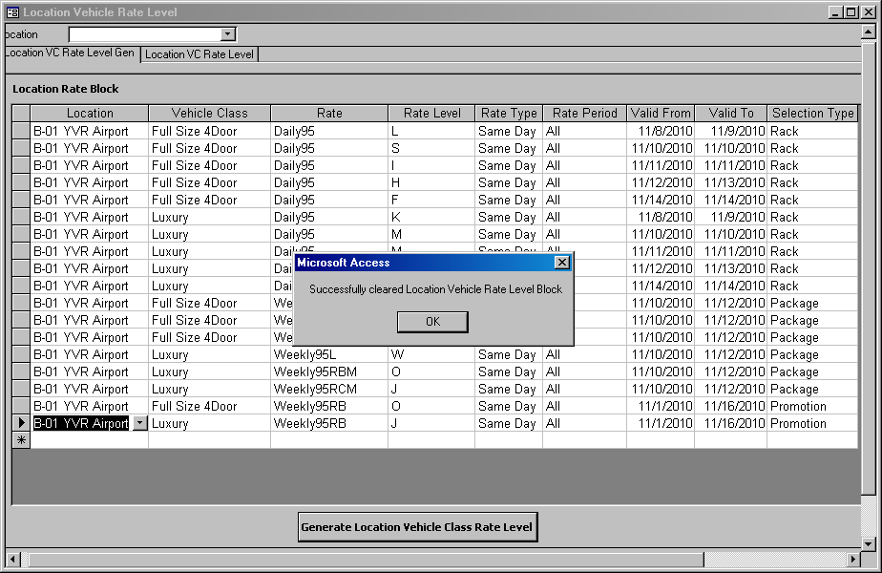
Figure 13: A message appears after you click the Generate Location Vehicle Class Rate Level button.

Let’s go back to our previous example. To see the generated daily rates, switch to the Location VC Rate Level sub-screen at the top portion of the screen. Since all the rates are created for B-01 YVR Airport, select said location from the Location drop down list and you will see that there each record you pasted had been drilled down and split into daily records (Recall that rate period ‘All’ refers to every day in the week), as shown in Figure 14.
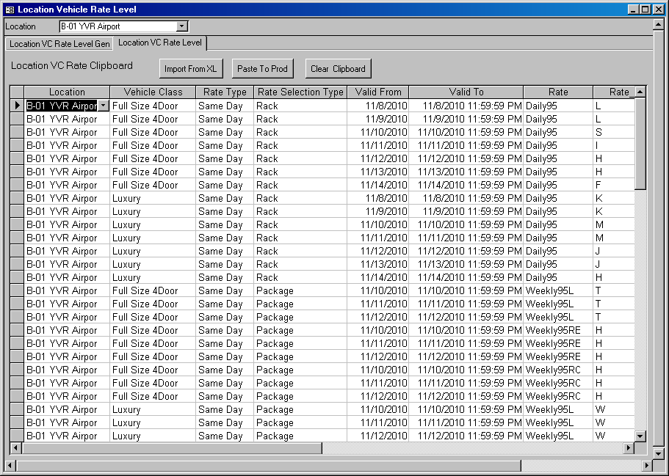
Figure 14: The generated daily rates for B-01 YVR Airport.
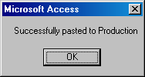
Now that you have all the rates ready, click the Paste To Prod button located at the top of the screen to transfer all your rates to production. When it is done, you will see the message in Figure 15.

Figure 15: Rates were copied ok.

Now that the rates are in production, let’s try it out. Today is Nov 9, 2010 and we shall make a reservation for Nov 9. Go to the Reservation screen, select B-01 YVR Airport as the Pick Up Location and Full Size 4Door as the Vehicle Class then click Get Data. If you go to the Rate/Base Rate sub-screen, you will see a default rate – Daily 95 Level L. This is the rack rate (refer back to Figure 14). Click on the View Rates button beside the rate field. A window will pop up and you will see a variety of package and promotion rates, as shown in Figure 16. If you select any of these package and promotion rates, you will notice that the rack rate is replaced by your selected rate. But you should also realize by now that you did not specify any package or promotion rates for Nov 9. So the existing package and promotion rate that was created by someone else in the system was not replaced following your rate update in the GIS Maintenance Tool.

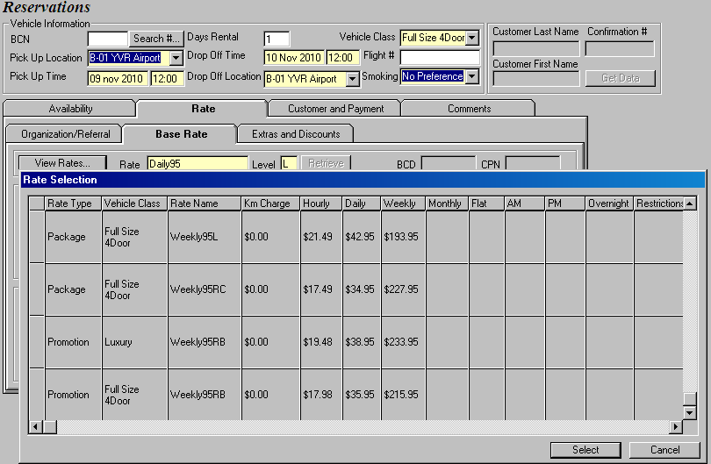
Figure 16: You can select from other (package/promotion/upsell) rates aside from the default rack rate.

Entering Organization BCD Rates

Entering organization BCD rates is similar to entering location vehicle class rates. Let’s return to the GIS Maintenance Tool again and select Rate Maintenance from the main menu. This time, however, select the Organization BCD Rate button to bring up the Organization Rate Input screen.

Again, you have to be extra careful when you prepare your organization BCD rates. Recall that your columns must be in the exact order of Organization, Rate, Rate Level, Valid From and Valid To prior to copying your rates to the GIS Maintenance Tool. See the sample organization BCD Excel rate sheet in Figure 17.

Copy the rates from your Excel sheet to the Organization Rate Input screen and select Move To Production to copy your rates to production (See Figure 18)and you’re done!

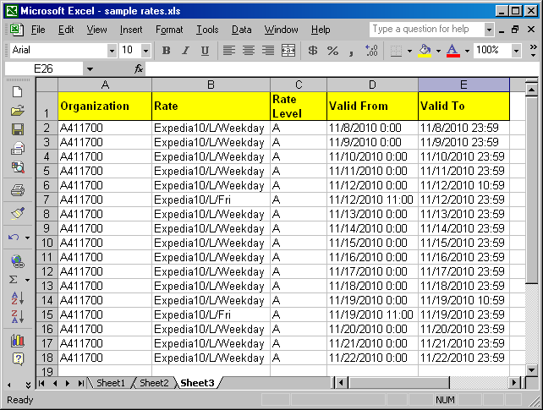
Figure 17: Sample organization BCD rates.

NOTE
Be extra careful so that your Valid From and Valid To dates do not overlap each other.

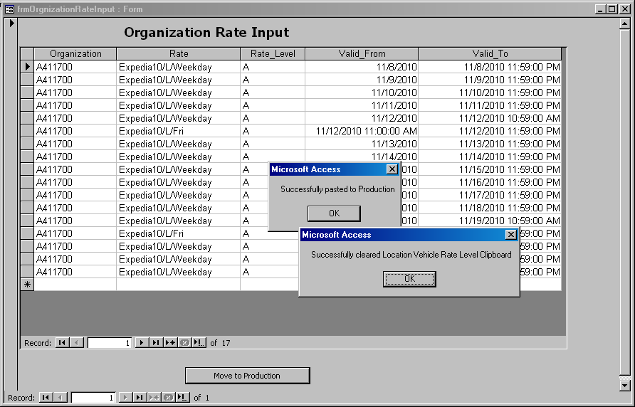
Figure 18: BCD rates were copied successfully.

